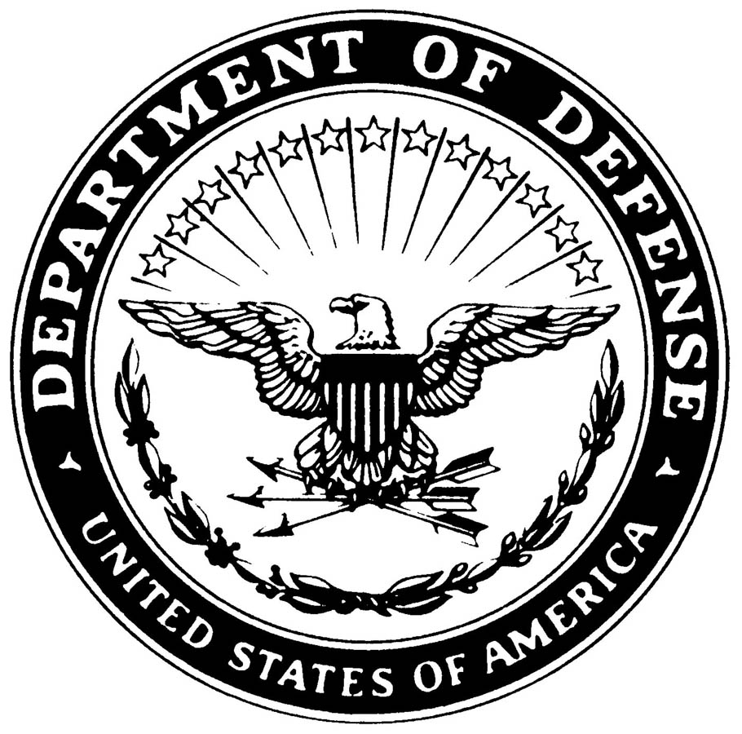
5813

IN REPLY REFER TO

UNITED STATES MARINE CORPS
LETTERHEAD OF
YOUR UNIT

1-07
1st # is which consecutive SCM it is for this CY. 2d # is CY.

SUMMARY COURT-MARTIAL CONVENING ORDER 1-07

Pursuant to the authority contained in paragraph 0120c of the Manual of the Judge Advocate General, Major John A. Doe, U.S. Marine Corps, is hereby detailed a summary courts-martial in the case of United States v. Lance Corporal John A. Smith, XXX-XX-1234, USMC.

I.M. Commander
Lieutenant Colonel, U.S. Marine Corps
Commanding

